INTERNATIONAL ORGANISATION FOR STANDARDISATION
ORGANISATION INTERNATIONALE DE NORMALISATION
ISO/IEC JTC1/SC29/WG11
CODING OF MOVING PICTURES AND AUDIO

ISO/IEC JTC1/SC29/WG11 N1909
MPEG97
Oct 1997/Fribourg

Source: Requirements, Audio, DMIF, SNHC, Systems, Video
Status: Final
Title: MPEG-4 Overview - (Fribourg Version)
Editor: Rob Koenen

Overview of the MPEG-4 Version 1 Standard
Executive Overview
MPEG-4 is an ISO/IEC standard being developed by MPEG (Moving Picture Experts Group), the committee which also developed the Emmy Award winning standards known as MPEG-1 and MPEG-2. These standards made interactive video on CD-ROM and Digital Television possible. MPEG-4 will be the result of another international effort involving hundreds of researchers and engineers from all over the world. MPEG-4, whose formal ISO/IEC designation will be ISO/IEC 14496, is to be released in November 1998 and will be an International Standard in January 1999.
MPEG-4 is building on the proven success of three fields: digital television, interactive graphics applications (synthetic content) and the World Wide Web (distribution of and access to content) and will provide the standardized technological elements enabling the integration of the production, distribution and content access paradigms of the three fields.

More information about MPEG-4 can be found at MPEG’s home page (case sensitive): HREF="http://www.cselt.it/mpeg. This web page contains links to a wealth of information about MPEG, including much about MPEG-4, many publicly available documents, several lists of ‘Frequently Asked Questions’ and links to other MPEG-4 web pages.
Table of Contents
Executive Overview
Table of Contents
1. Scope and features of the MPEG-4 standard
1.1 Representation of primitive AVOs
1.2 Composition of AVOs
1.3 Multiplexing and Synchronization of AVOs
1.4 Interaction with AVOs
1.5 Identification and Protection of Intellectual Property Rights of AVOs
2. Detailed technical description of the MPEG-4 standard
2.1 DMIF
2.2 Demultiplexing, buffer management and time identification
2.3 Syntax Description
2.4 Coding of Audio Objects
2.5 Coding of Visual Objects
2.6 Scene description
2.7 User interaction
2.8 Content-related IPR identification and protection
3. List of major functionalities provided by MPEG-4 in November ’98
3.1 DMIF
3.2 Systems
3.3 Audio
3.4 Visual
4. Annexes
Annex A - The MPEG-4 development process
Annex B - Organization of work in MPEG
Annex C - Glossary and Acronyms

Scope and features of the MPEG-4 standard
The MPEG-4 standard under development will provide a set of technologies to satisfy the needs of authors, service providers and end users alike.
- For authors, MPEG-4 will enable the production of content that has far greater reusability, has greater flexibility than is possible today with individual technologies such as digital television, animated graphics, World Wide Web (WWW) pages and their extensions. Also, it will be possible to better manage and protect content owner rights.
- For network service providers MPEG-4 will offer transparent information which will be interpreted and translated into the appropriate native signaling messages of each network with the help of relevant standards bodies having the appropriate jurisdiction. However the foregoing excludes Quality of Service considerations, for which MPEG-4 will provide a generic QoS parameter set for different MPEG-4 media. The exact mapping for these translations are beyond the scope of MPEG-4 and are left to be defined by network providers. Signaling of the QoS information end-to-end, will enable transport optimization in heterogeneous networks.
- For end users, MPEG-4 will enable many functionalities which could potentially be accessed on a single compact terminal and higher levels of interaction with content, within the limits set by the author. An MPEG-4 applications document exists which describes many end user applications including, among others, real time communications, surveillance and mobile multimedia.
For all parties involved, MPEG wants to avoid the emergence of a multitude of proprietary, non-interworking formats and players.

MPEG-4 achieves these goals by providing standardized ways to:
- represent units of aural, visual or audiovisual content, called “audio/visual objects” or AVOs. (The very basic unit is more precisely called a “primitive AVO”). These AVOs can be of natural or synthetic origin; this means they could be recorded with a camera or microphone, or generated with a computer;
- compose these objects together to create compound audiovisual objects that form audiovisual scenes;
- multiplex and synchronize the data associated with AVOs, so that they can be transported over network channels providing a QoS appropriate for the nature of the specific AVOs; and
- interact with the audiovisual scene generated at the receiver’s end.

The following sections illustrate the MPEG-4 functionalities described above, using the audiovisual scene depicted in Figure 1.

Representation of primitive AVOs
Audiovisual scenes are composed of several AVOs, organized in a hierarchical fashion. At the leaves of the hierarchy, we find primitive AVOs, such as :
- a 2-dimensional fixed background,
- the picture of a talking person (without the background)
- the voice associated with that person;
- etc.

MPEG standardizes a number of such primitive AVOs, capable of representing both natural and synthetic content types, which can be either 2- or 3-dimensional. In addition to the AVOs mentioned above and shown in Figure 1, MPEG-4 defines the coded representation of objects such as:
- text and graphics;
- talking heads and associated text to be used at the receiver’s end to synthesize the speech and animate the head;
- animated human bodies.

In their coded form, these objects are represented as efficiently as possible. This means that the bits used for coding these objects are no more than necessary for support of desired functionalities. Examples of such functionalities are error robustness, allowing extraction and editing of an object, or having an object available in a scaleable form. It is important to note that in their coded form, objects (aural or visual) can be represented independent of their surroundings or background.

Composition of AVOs
Figure 1 gives an example that highlights the way in which an audiovisual scene in MPEG-4 is composed of individual objects. The figure contains compound AVOs that group elementary AVOs together. As an example: the visual object corresponding to the talking person and the corresponding voice are tied together to form a new compound AVO, containing both the aural and visual components of a talking person.

Such grouping allows authors to construct complex scenes, and enables consumers to manipulate meaningful (sets of) objects.

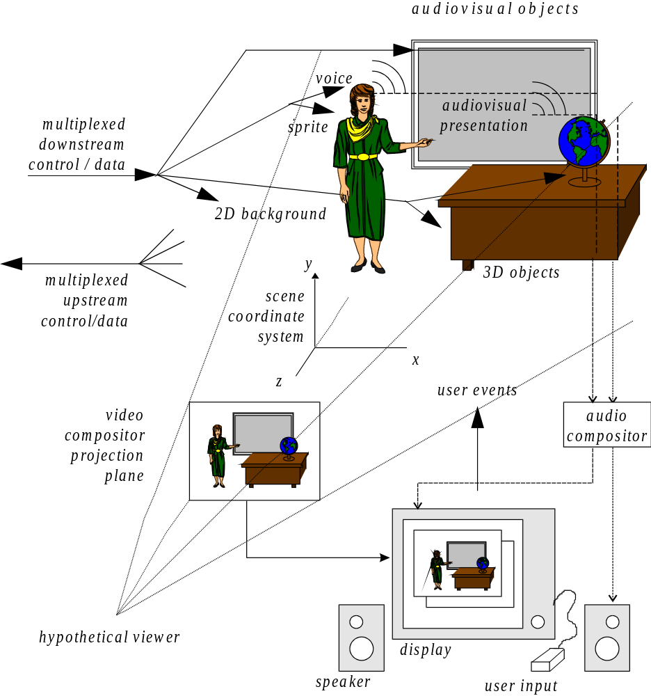
Figure 1 - An example of an MPEG-4 audiovisual scene

More generally, MPEG-4 provides a standardized way to compose a scene, allowing for example to:
- place AVOs anywhere in a given coordinate system;
- group primitive AVOs in order to form compound AVOs;
- apply streamed data to AVOs, in order to modify their attributes (e.g. moving texture belonging to an object; animating a moving head be sending animation parameters);
- change, interactively, the user’s viewing and listening points anywhere in the scene.
The scene composition borrows several concepts from VRML in terms of both its structure and the functionality of object composition nodes.

Multiplexing and Synchronization of AVOs
AV object data is conveyed in one or more Elementary Streams. The streams are characterized by the Quality of Service (QoS) they request for transmission (e.g., maximum bit rate, bit error rate, etc.), as well as other parameters, including stream type information to determine the required decoder resources and the precision for encoding timing information. How such streaming information is transported in a synchronized manner from source to destination, exploiting different QoS as available from the network, is specified in terms of an Access Unit Layer and a conceptual two-layer multiplexer, as depicted in Figure 2

The Access Unit Layer allows identification of Access Units (e.g., video or audio frames, scene description commands) in Elementary Streams, recovery of the AV object’s or scene description’s time base and enables synchronization among them. The Access Unit header can be configured in a large number of ways, allowing use in a broad spectrum of systems.

The “FlexMux” (Flexible Multiplexing) Layer is fully specified by MPEG. It contains a multiplexing tool which allows grouping of Elementary Streams (ESs) with a low multiplexing overhead. This may be used, for example, to group ES with similar QoS requirements.

The “TransMux” (Transport Multiplexing) layer in Figure 2 models the layer that offers transport services matching the requested QoS. Only the interface to this layer is specified by MPEG-4. Any suitable existing transport protocol stack such as (RTP)/UDP/IP, (AAL5)/ATM, or MPEG-2’s Transport Stream over a suitable link layer may become a specific TransMux instance. The choice is left to the end user/service provider, and allows MPEG-4 to be used in a wide variety of operation environments.

Use of the FlexMux multiplexing tool is optional and, as shown in Figure 2, this layer may be bypassed if the underlying TransMux instance provides equivalent functionality. The Access Unit Layer, however, is always present.

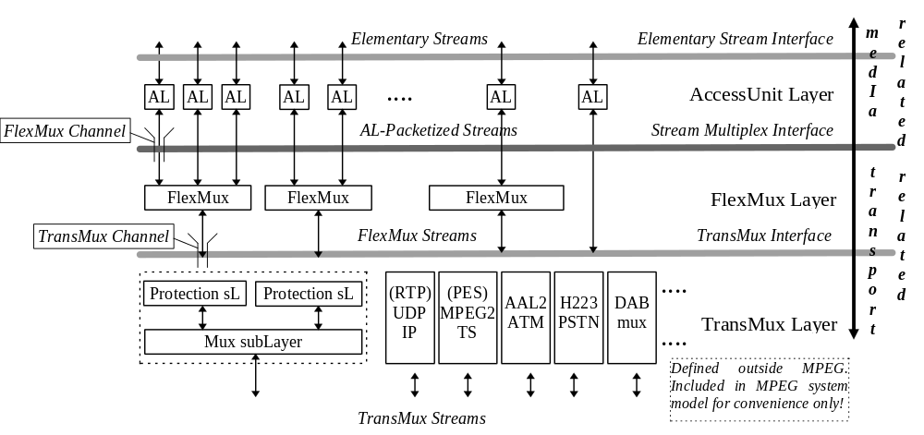
Figure 2 - The MPEG-4 System Layer Model

With regard to Figure 2, it will be possible to:
- identify access units, transport timestamps and clock reference information and identify data loss.
- optionally interleave data from different ESs into FlexMux Streams
- convey control information to
- indicate the required QoS for each Elementary Stream and FlexMux stream;
- translate such QoS requirements into actual network resources;
- convey the mapping of ESs, associated to AVOs, to FlexMux and TransMux channels
Part of the control functionalities will be available only in conjunction with a transport control entity like the DMIF framework.

Interaction with AVOs
In general, the user observes a scene that is composed following the design of the scene’s author. Depending on the degree of freedom allowed by the author, however, the user has the possibility to interact with the scene. Operations a user may be allowed to perform include:
- change the viewing/listening point of the scene, e.g. by navigation through a scene;
- drag objects in the scene to a different position;
- trigger a cascade of events by clicking on a specific object, e.g. starting or stopping a video stream ;
- select the desired language when multiple language tracks are available;
- more complex kinds of behavior can also be triggered, e.g. a virtual phone rings, the user answers and a communication link is established.

Identification and Protection of Intellectual Property Rights of AVOs
It is important to have the possibility to store IPR information associated with MPEG-4 AVOs. To this end, MPEG works with representatives of rights holders’ organizations in the definition of syntax and tools to support IPR identification and protection. The MPEG-4 standard will incorporate the functionality to store the unique identifiers issued by international numbering systems; these numbers can be applied to identify a current rights holder. Protection of content will be addressed in MPEG-4 Version 2.

Detailed technical description of the MPEG-4 standard
As shown in Figure 3, streams coming from the network (or a storage device) as TransMux Streams are demultiplexed into FlexMux Streams and passed to appropriate FlexMux demultiplexers that retrieve Elementary Streams. This is described in Section 2.2. The Elementary Streams (ESs) are parsed and passed to the appropriate decoders. Decoding recovers the data in an AV object from its encoded form and performs the necessary operations to reconstruct the original AV object ready for rendering on the appropriate device. Audio and visual objects are represented in their coded form which is described in sections 2.4 and 2.5. The reconstructed AV object is made available to the composition layer for potential use during scene rendering. Decoded AVOs, along with scene description information, are used to compose the scene as described by the author. Scene description is explained in Section 2.6, and Composition in Section 2.7. The user can, to the extent allowed by the author, interact with the scene which is eventually rendered and presented. Section 2.8 describes this interaction.

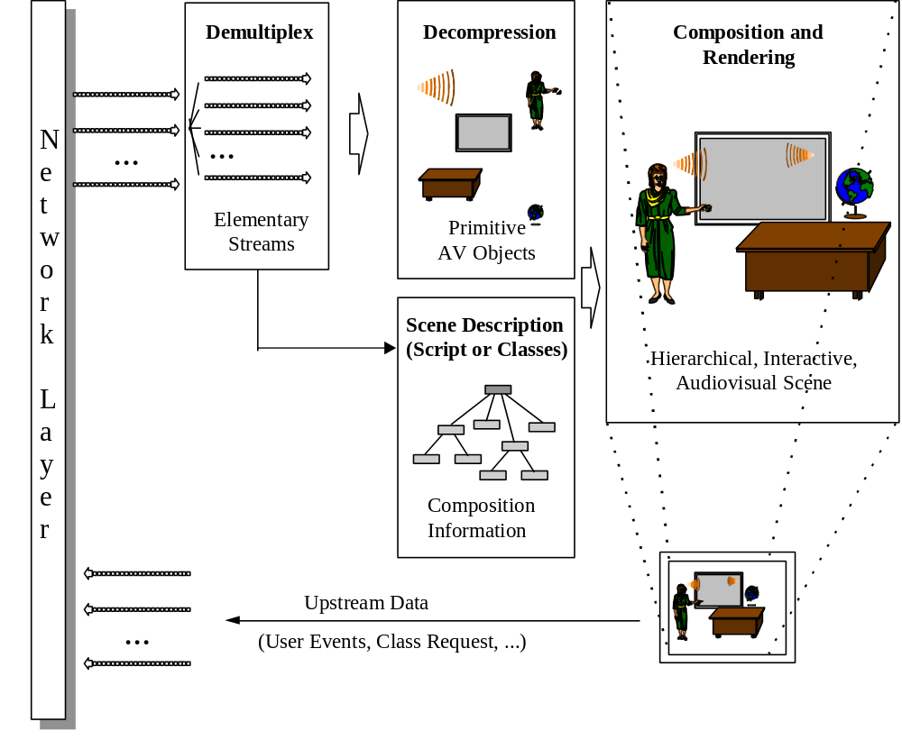

Figure 3- Major components of an MPEG-4 terminal (receiver side)

DMIF
The Delivery Multimedia Integration Framework (DMIF) addresses operation of multimedia applications over interactive networks, in broadcast environments and from disks. The DMIF architecture is such that applications which rely on DMIF for communications do not have to be concerned with the underlying communications method. The implementation of DMIF takes care of the network details presenting the application with a simple interface.

Figure 2 below.DMIF (Delivery Multimedia Integration Framework) is located between the MPEG-4 application and the transport network as shown in Figure 4 below.
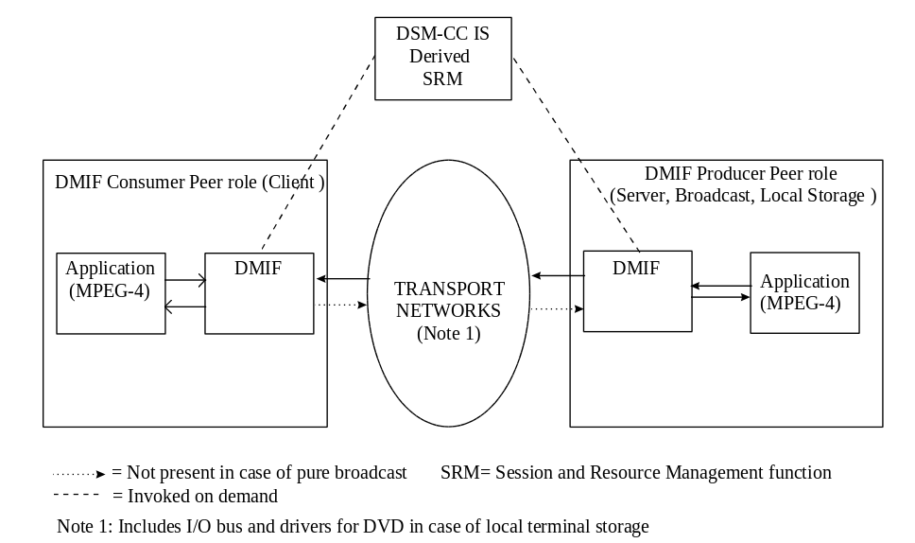
Figure 4 The DMIF Architecture
To the application, DMIF presents a consistent interface irrespective of whether MPEG-4 streams are received by interacting with a remote interactive DMIF peer over networks and/or by interacting with broadcast or storage media. An interactive DMIF peer as shown in Figure 4, is an end-system on a network which can originate a session with a target peer. A target peer can be an interactive peer, a set of broadcast MPEG-4 streams or a set of stored MPEG-4 files.

An MPEG-4 application through the DMIF interface can establish a multiple peer application session. Each peer is identified by a unique address. A peer may be a remote interactive peer over a network or can be pre-cast (over broadcast or storage media). An interactive peer irrespective of whether it initiated the session can select a service, obtain a scene description and request specific streams for AVOs from the scene to be transmitted with the appropriate QoS.

The MPEG-4 application can request from DMIF the establishment of channels with specific QoSs and bandwidths for each elementary stream. DMIF ensures the timely establishment of the channels with the specified bandwidths while preserving the QoSs over a variety of intervening networks between the interactive peers. DMIF allows each peer to maintain its own view of the network, thus reducing the number of stacks supported at each terminal. Control of DMIF spans both the FlexMux and the TransMux layers shown in Figure 2 above. In the case of FlexMux, DMIF provides control of the establishment of FlexMux channels. In the case of TransMux, DMIF uses an open interface which accommodates existing and future networks through templates called connection resource descriptors. MPEG-4 will offer a transparent interface with signaling primitive semantics. These MPEG-4 semantics at the interface to DMIF are interpreted and translated into the appropriate native signaling messages of each network, with the help of relevant standards bodies having the appropriate jurisdiction. In the area of QoS, MPEG-4 provides a first step towards defining a generic QoS parameter set for media at the DMIF interface. The exact mapping for these translations are beyond the scope of MPEG-4 and are left to be defined by network providers.

The DMIF SRM functionality in Figure 4 encompasses the MPEG-2 DSM-CC SRM functionality. However, unlike DSM-CC, DMIF allows the choice whether or not to invoke SRM. DMIF provides a globally unique network session identifier which can be used to tag the resources and log their usage for subsequent billing.

In a typical operation an end-user may access AVOs distributed over a number of remote interactive peers, broadcast and storage systems. The initial network connection to an interactive peer may consist of a best effort connection over a ubiquitous network. If the content warrants it, the end-user may seamlessly scale up the quality by adding enhanced AVO streams over connection resources with guaranteed QoS.

Demultiplexing, buffer management and time identification

Individual Elementary Streams have to be retrieved from incoming data from some network connection or a storage device. Each network connection or file is homogeneously considered a TransMux Channel in the MPEG-4 system model. The demultiplexing is partially or completely done by layers outside the scope of MPEG-4, depending on the application. For the purpose of integrating MPEG-4 in system environments, the Stream Multiplex Interface (see Figure 2) is the reference point. Adaptation Layer-packetized Streams are delivered at this interface. The FlexMux Layer specifies the optional FlexMux tool. The TransMux Interface specifies how either AL-packetized Streams (no FlexMux used) or FlexMux Streams are to be retrieved from the TransMux Layer. This is the interface to the transport functionalities not defined by MPEG. The data part of the interfaces is considered here while the control part is dealt with by DMIF.

In the same way that MPEG-1 and MPEG-2 described the behavior of an idealized decoding device along with the bitstream syntax and semantics, MPEG-4 defines a System Decoder Model. This allows the precise definition of the terminal’s operation without making unnecessary assumptions about implementation details. This is essential in order to give implementers the freedom to design real MPEG-4 terminals and decoding devices in a variety of ways. These devices range from television receivers which have no ability to communicate with the sender to computers which are fully enabled with bi-directional communication. Some devices will receive MPEG-4 streams over isochronous networks while others will use non-isochronous means (e.g., the Internet) to exchange MPEG-4 information. The System Decoder Model provides a common model on which all implementations of MPEG-4 terminals can be based.

The specification of a buffer and timing models is essential to encoding devices which may not know ahead of time what the terminal device is or how it will receive the encoded stream. Though the MPEG-4 specification will enable the encoding device to inform the decoding device of resource requirements, it may not be possible, as indicated earlier, for that device to respond to the sender. It is also possible that an MPEG-4 session is received simultaneously by widely different devices; it will, however, be properly rendered according to the capability of each device.

Demultiplexing
The retrieval of incoming data streams from network connections or storage media consists of two tasks. First, the channels must be located and opened. This requires a transport control entity, e.g., DMIF. Second, the incoming streams must be properly demultiplexed to recover the Elementary Streams from downstream channels (incoming at the receiving terminal). In interactive applications, a corresponding multiplexing stage will multiplex upstream data in upstream channels (outgoing from the receiving terminal). These elementary streams carry either AV object data, scene description information, or control information related to AV objects or to system management.

The MPEG-4 demultiplexing stage is specified in terms of a conceptual two-layer multiplexer consisting of a TransMux Layer and a FlexMux Layer as well as an Access Unit Layer that conveys synchronization information.

The generic term ‘TransMux Layer’ is used to abstract any underlying multiplex functionality – existing or future – that is suitable to transport MPEG-4 data streams. Note that this layer is not defined in the context of MPEG-4. Examples are MPEG-2 Transport Stream, H.223, ATM AAL 2, IP/UDP. The TransMux Layer is modeled as consisting of a protection sublayer and a multiplexing sublayer indicating that this layer is responsible for offering a specific QoS. Protection sublayer functionality includes error protection and error detection tools suitable for the given network or storage medium. In some TransMux instances, it may not be possible to separately identify these sublayers.

In any concrete application scenario one or more specific TransMux Instances will be used. Each TransMux demultiplexer gives access to TransMux Channels. The requirements on the data interface to access a TransMux Channel are the same for all TransMux Instances. They include the need for reliable error detection, delivery, if possible, of erroneous data with a suitable error indication and framing of the payload which may consist of either AL-packetized streams or FlexMux streams. These requirements are summarized in an informative way in the TransMux Interface, in the Systems part of the MPEG-4 Standard.

The FlexMux layer, on the other hand, is completely specified by MPEG. It provides a flexible, low overhead, low delay tool for interleaving data that may optionally be used and is especially useful when the packet size or overhead of the underlying TransMux instance is large. The FlexMux is not itself robust to errors and can either be used on TransMux Channels with a high QoS or to bundle Elementary Streams that are equally error tolerant. The FlexMux requires reliable error detection and sufficient framing of FlexMux packets (for random access and error recovery) from the underlying layer. These requirements are summarized in the Stream Multiplex Interface which defines the data access to individual transport channels. The FlexMux demultiplexer retrieves AL-packetized streams from FlexMux Streams.

The Access Unit Layer has a minimum set of tools for consistency checking, padding, to convey time base information and to carry time stamped Access Units of an Elementary Stream. Each packet consists of one Access Unit or a fragment of an Access Unit. These time stamped Access Units form the only semantic structure of Elementary Streams that is visible on this layer. The AU Layer requires reliable error detection and framing of each individual packet from the underlying layer, which can be accomplished, e.g., by using the FlexMux. How data can be accessed by the compression layer is summarized in the informative Elementary Stream Interface, which can be found in the Systems part of the MPEG-4 Standard. The AU Layer retrieves Elementary Streams from AL-packetized Streams.

To be able to relate Elementary Streams to AV objects within a scene, Object Descriptors and StreamMapTables are used. Object Descriptors convey information about the number and properties of Elementary Streams that are associated to particular AV objects. The StreamMapTable links each stream to a ChannelAssociationTag that serves as a handle to the channel that carries this stream. Resolving ChannelAssociationTags to the actual transport channel as well as the management of the sessions and channels is addressed by the DMIF part of the MPEG-4 standard.

Buffer Management
To predict how the decoder will behave when it decodes the various elementary data streams that form an MPEG-4 session, the Systems Decoder Model enables the encoder to specify and monitor the minimum buffer resources that are needed to decode a session. The required buffer resources are conveyed to the decoder within Object Descriptors during the setup of the MPEG-4 session, so that the decoder can decide whether it is capable of handling this session.
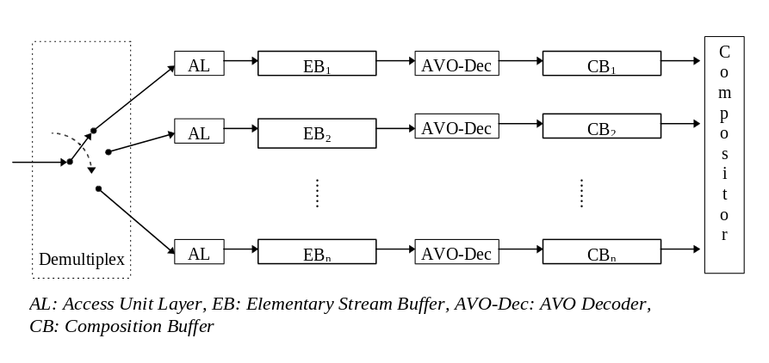
Figure 5 - Buffer architecture of the System Decoder Model

By managing the finite amount of buffer space the model allows a sender, for example, to transfer non real-time data ahead of time if sufficient space is available at the receiver side to store it. The pre-stored data can then be accessed when needed, allowing at that time real-time information to use a larger amount of the channel’s capacity if so desired.

Time Identification
For real time operation, a timing model is assumed in which the end-to-end delay from the signal output from an encoder to the signal input to a decoder is constant. Furthermore, the transmitted data streams must contain implicit or explicit timing information. There are two types of timing information. The first is used to convey the speed of the encoder clock, or time base, to the decoder. The second, consisting of time stamps attached to portions of the encoded AV data, contains the desired decoding time for Access Units or composition and expiration time for Composition Units. This information is conveyed in AL-PDU Headers generated in the Access Unit Layer. With this timing information, the inter-picture interval and audio sample rate can be adjusted at the decoder to match the encoder’s inter-picture interval and audio sample rate for synchronized operation.

Different AV objects may be encoded by encoders with different time bases, with the accompanying slightly different speed. It is always possible to map these time bases to the time base of the receiving terminal. In this case, however, no real implementation of a receiving terminal can avoid the occasional repetition or drop of AV data, due to temporal aliasing (relative reduction or extension of their time scale).

Although systems operation without any timing information is allowed, defining a buffering model is not possible.

Syntax Description
MPEG-4 defines a syntactic description language to describe the exact binary syntax of an AV object’s bitstream representation as well as that of the scene description information. This is a departure from MPEG’s traditional approach of utilizing pseudo C. This language is an extension of C++, and is used to describe the syntactic representation of objects and the overall AV object class definitions and scene description information in an integrated way. This provides a consistent and uniform way of describing the syntax in a very precise form, while at the same time simplifying bitstream compliance testing. Software tools can be used to process the syntactic description and generate the necessary code for programs that perform validation.

Coding of Audio Objects
MPEG-4 coding of audio objects provides tools for representing natural sounds (such as speech and music) and for synthesizing sounds based on structured descriptions. The representations provide compression and other functionalities, such as scalability or playing back at different speeds. The representation for synthesized sound can be formed by text or instrument descriptions and by coding parameters to provide effects such as reverberation and spatialization.

Natural Sound
MPEG-4 standardizes natural audio coding at bitrates ranging from 2 kbit/s up to 64 kbit/s. The presence of the MPEG-2 AAC standard within the MPEG-4 tool set will provide for general compression of audio in the upper bit rate range. For the bitrates from 2 kbit/s up to 64 kbit/s, the MPEG-4 standard normalizes the bitstream syntax and decoding processes in terms of a set of tools. In order to achieve the highest audio quality within the full range of bitrates and at the same time provide the extra functionalities, three types of coder have been defined. The lowest bitrate range i.e. 2 - 4 kbit/s for speech with 8 kHz sampling frequency and 4 - 16 kbit/s for audio with 8 or 16 kHz sampling frequency, is covered by parametric coding techniques. Speech coding at the medium bitrates between about 6 - 24 kbit/s uses Code Excited Linear Predictive (CELP) coding techniques. In this region, two sampling rates, 8 and 16 kHz, are used to support both narrowband and wideband speech, respectively. For bitrates starting below 16 kbit/s, time to frequency (T/F) coding techniques, namely the TwinVQ and AAC codecs, are applied. The audio signals in this region typically have sampling frequencies starting at 8 kHz.
To allow for smooth transitions between the bitrates and to allow for bitrate and bandwidth scalability, a general framework has been defined. This is illustrated in Figure 6.
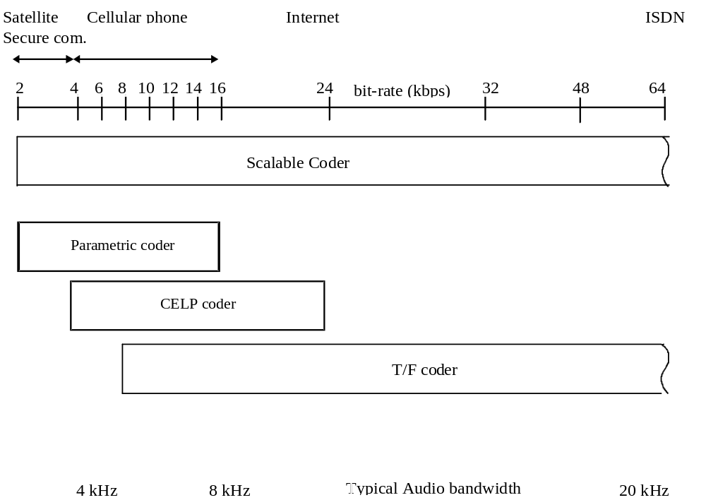
Figure 6 - General block diagram of MPEG-4 Audio

Starting with a coder operating at a low bitrate, by adding enhancements, such as the addition of BSAC to an AAC coder for fine grain scalability, both the coding quality as well as the audio bandwidth can be improved. These enhancements are realized within a single coder or, alternatively, by combining different techniques.

The MPEG-4 systems layer facilitates the use of different tools and signaling this, and thus codecs according to existing standards can be accommodated. Therefore MPEG-4 allows the use of several highly optimized coders, such as those standardized by the ITU-T, which were designed to meet a specific set of requirements. Each of the coders is designed to operate in a stand-alone mode with its own bitstream syntax. Additional functionalities are realized both within individual coders, and by means of additional tools around the coders. An example of a functionality within an individual coder is pitch change within the parametric coder.

Synthesized Sound
Decoders are also available for generating sound based on structured inputs. Text input is converted to speech in the Text-To-Speech (TTS) decoder, while more general sounds including music may be normatively synthesized. Synthetic music may be delivered at extremely low bitrates while still describing an exact sound signal.

Text To Speech. TTS allows a text or a text with prosodic parameters (pitch contour, phoneme duration, and so on) as its inputs to generate intelligible synthetic speech. It includes the following functionalities.
- Speech synthesis using the prosody of the original speech
- Facial animation control with phoneme information.
- Trick mode functionality: pause, resume, jump forward/backward.
- International language support for text.
- International symbol support for phonemes.
- support for specifying age, gender, language and dialect of the speaker

Score Driven Synthesis.
The Structured Audio Decoder decodes input data and produces output sounds. This decoding is driven by a special synthesis language called SAOL (Structured Audio Orchestra Language) standardized as part of MPEG-4. This language is used to define an “orchestra” made up of “instruments” (downloaded in the bitstream, not fixed in the terminal) which create and process control data. An instrument is a small network of signal processing primitives that might emulate some specific sounds such as those of a natural acoustic instrument. The signal-processing network may be implemented in hardware or software and include both generation and processing of sounds and manipulation of prestored sounds.

MPEG-4 does not standardize “a method” of synthesis, but rather a method of describing synthesis. Any current or future sound-synthesis method can be described in SAOL, including wavetable, FM, additive, physical-modeling, and granular synthesis, as well as non-parametric hybrids of these methods.

Control of the synthesis is accomplished by downloading “scores” or “scripts” in the bitstream. A score is a time-sequenced set of commands that invokes various instruments at specific times to contribute their output to an overall music performance or generation of sound effects. The score description, downloaded in a language called SASL (Structured Audio Score Language), can be used to create new sounds, and also include additional control information for modifying existing sound. This allows the composer finer control over the final synthesized sound. For synthesis processes which do not require such fine control, the established MIDI protocol may also be used to control the orchestra.

Careful control in conjunction with customized instrument definition, allows the generation of sounds ranging from simple audio effects such as footsteps or door closures, to the simulation of natural sounds such as rainfall or music played on conventional instruments to fully synthetic sounds for complex audio effects or futuristic music.

All of these capabilities are completely normalized in MPEG-4, and thus the sound is guaranteed to be exactly the same on every terminal. For terminals with less functionality, and for applications which do not require such sophisticated synthesis, a “wavetable bank format” is also standardized. Using this format, sound samples for use in wavetable synthesis may be downloaded, as well as simple processing such as filters, reverbs, and chorusers. With this tool, sound quality is still normative, but less functionality is provided. In this case, the computational complexity of the required decoding process may be exactly determined from inspection of the bitstream, which is not possible when using SAOL.

Effects
As well as being used for defining instruments, the SAOL language is used to describe special processing effects for use in the MPEG-4 Systems Binary Format for Scene Description. The Audio BIFS system processes decoded audio data to provide an output data stream that has been manipulated for special effects with timing accuracy consistent with the effect and the audio sampling rate. The effects are essentially specialized “instrument” descriptions serving the function of effects processors on the input streams. The effects processing includes reverberators, spatializers, mixers, limiters, dynamic range control, filters, flanging, chorus or any hybrid of these effects.

Thus, within MPEG-4, delivery of truly Synthetic/Natural Hybrid (SNHC) content is possible. An overall MPEG-4 bitstream may include both Natural audio, coded as described above, and Synthetic music, speech, and sound effects; then, a BIFS scene graph can be used to mix, post-produce, spatialize, and allow interaction with all of the decoded audio.

Coding of Visual Objects
Visual objects can be either of natural or of synthetic origin. First, the objects of natural origin are described.

Natural Textures, Images and Video
The tools for representing natural video in the MPEG-4 visual standard aim at providing standardized core technologies allowing efficient storage, transmission and manipulation of textures, images and video data for multimedia environments. These tools will allow the decoding and representation of atomic units of image and video content, called “video objects” (VOs). An example of a VO could be a talking person (without background) which can then be composed with other AVOs (audio-visual objects) to create a scene. Conventional rectangular imagery is handled as a special case of such objects.

In order to achieve this broad goal rather than a solution for a narrow set of applications, functionalities common to several applications are clustered. Therefore, the visual part of the MPEG-4 standard provides solutions in the form of tools and algorithms for:
- efficient compression of images and video
- efficient compression of textures for texture mapping on 2D and 3D meshes
- efficient compression of implicit 2D meshes
- efficient compression of time-varying geometry streams that animate meshes
- efficient random access to all types of visual objects
- extended manipulation functionality for images and video sequences
- content-based coding of images and video
- content-based scalability of textures, images and video
- spatial, temporal and quality scalability
- error robustness and resilience in error prone environments

The visual part of the MPEG-4 standard will provide a toolbox containing tools and algorithms bringing solutions to the above mentioned functionalities and more.

Synthetic Objects
Synthetic objects form a subset of the larger class of computer graphics, as an initial focus the following visual synthetic objects will be described:
- Parametric descriptions of
- a synthetic description of human face and body
- animation streams of the face and body
- Static and Dynamic Mesh Coding with texture mapping
- Texture Coding for View Dependent applications

facial animation
The face is an object capable of facial geometry ready for rendering and animation. The shape, texture and expressions of the face are generally controlled by the bitstream containing instances of Facial Definition Parameter (FDP) sets and/or Facial Animation Parameter (FAP) sets. Upon construction, the Face object contains a generic face with a neutral expression. This face can already be rendered. It is also immediately capable of receiving the FAPs from the bitstream, which will produce animation of the face: expressions, speech etc. If FDPs are received, they are used to transform the generic face into a particular face determined by its shape and (optionally) texture. Optionally, a complete face model can be downloaded via the FDP set as a scene graph for insertion in the face node.
The Face object can also receive local controls that can be used to modify the look or behavior of the face locally by a program or by the user. There are three possibilities of local control. First, by sending locally a set of FDPs to the Face the shape and/or texture can be changed. Second, a set of Amplification Factors can be defined, each factor corresponding to an animation parameter in the FAP set. The face object will apply these Amplification Factors to the FAPs, resulting in amplification or attenuation of selected facial actions. This feature can be used for example to amplify the visual effect of speech pronunciation for easier lip reading. The third local control is allowed through the definition of the Filter Function. This function, if defined, will be invoked by the Face object immediately before each rendering. The Face object passes the original FAP set to the Filter Function, which applies any modification to it and returns it to be used for the rendering. The Filter Function can include user interaction. It is also possible to use the Filter Function as a source of facial animation if there is no bitstream to control the face, e.g. in the case where the face is driven by a TTS system that in turn is driven uniquely by text coming through the bitstream.

body animation
The Body is an object capable of producing virtual body models and animations in form of a set of 3D polygon meshes ready for rendering. Two sets of parameters are defined for the body: Body Definition Parameter (BDP) set, and Body Animation Parameter (BAP) set. The BDP set defines the set of parameters to transform the default body to a customized body with its body surface, body dimensions, and (optionally) texture. The Body Animation Parameters (BAP)s, if correctly interpreted, will produce reasonably similar high level results in terms of body posture and animation on different body models, without the need to initialize or calibrate the model.

Upon construction, the Body object contains a generic virtual human body with the default posture. This body can already be rendered. It is also immediately capable of receiving the BAPs from the bitstream, which will produce animation of the body. If BDPs are received, they are used to transform the generic body into a particular body determined by the parameters contents. Any component can be null. A null component is replaced by the corresponding default component when the body is rendered. The default posture is defined by standing posture. This posture is defined as follows: the feet should point to the front direction, the two arms should be placed on the side of the body with the palm of the hands facing inward. This posture also implies that all BAPs have default values.

No assumption is made and no limitation is imposed on the range of motion of joints. In other words the human body model should be capable of supporting various applications, from realistic simulation of human motions to network games using simple human-like models.

2D animated meshes

A 2D mesh is a tessellation (or partition) of a 2D planar region into polygonal patches. The vertices of the polygonal patches are referred to as the node points of the mesh. MPEG4 considers only triangular meshes where the patches are triangles. A 2D dynamic mesh refers to 2D mesh geometry and motion information of all mesh node points within a temporal segment of interest. Triangular meshes have long been used for efficient 3D object shape (geometry) modeling and rendering in computer graphics. 2D mesh modeling may be considered as projection of such 3D triangular meshes onto the image plane. An example of a 2D mesh is depicted in Figure 7.


Figure 7- 2D mesh modeling of the "Akiyo" video object

A dynamic mesh is a forward tracking mesh, where the node points of the initial mesh track image features forward in time by their respective motion vectors. The initial mesh may be regular, or can be adapted to the image content, which is called a content-based mesh . 2D content-based mesh modeling then corresponds to non-uniform sampling of the motion field at a number of salient feature points (node points) along the contour and interior of a video object. Methods for selection and tracking of these node points are not subject to standardization.

In 2D mesh based texture mapping, triangular patches in the current frame are deformed by the movements of the node points into triangular patches in the reference frame, and the texture inside each patch in the reference frame is warped onto the current frame using a parametric mapping, defined as a function of the node point motion vectors. For triangular meshes, the affine mapping is a common choice. Its linear form implies texture mapping with low computational complexity. Affine mappings can model translation, rotation, scaling, reflection and shear, and preserve straight lines. The degrees of freedom given by the three motion vectors of the vertices of a triangle match with the six parameters of the affine mapping. This implies that the original 2D motion field can be compactly represented by the motion of the node points, from which a continuous, piece-wise affine motion field can be reconstructed. At the same time, the mesh structure constrains movements of adjacent image patches. Therefore, meshes are well-suited to represent mildly deformable but spatially continuous motion fields.

The attractiveness of 2D mesh modeling originates from the fact that 2D meshes can be designed from a single view of an object without requiring range data, while maintaining several of the functionalities offered by 3D mesh modeling. In summary, the 2D object-based mesh representation is able to model the shape (polygonal approximation of the object contour) and motion of a VOP in a unified framework, which is also extensible to the 3D object modeling when data to construct such models is available. In particular, the 2D mesh representation of video objects enables the following functionalities:

Video Object Manipulation
- Augmented reality: Merging virtual (computer generated) images with real moving images (video) to create enhanced display information. The computer-generated images must remain in perfect registration with the moving real images (hence the need for tracking).
- Synthetic-object-transfiguration/animation: Replacing a natural video object in a video clip by another video object. The replacement video object may be extracted from another natural video clip or may be transfigured from a still image object using the motion information of the object to be replaced (hence the need for a temporally continuous motion representation).
- Spatio-temporal interpolation: Mesh motion modeling provides more robust motion-compensated temporal interpolation (frame rate up-conversion).
Video Object Compression
- 2D mesh modeling may be used for compression if one chooses to transmit texture maps only at selected key frames and animate these texture maps (without sending any prediction error image) for the intermediate frames. This is also known as self-transfiguration of selected key frames using 2D mesh information.
Content-Based Video Indexing
- Mesh representation enables animated key snapshots for a moving visual synopsis of objects.
- Mesh representation provides accurate object trajectory information that can be used to retrieve visual objects with specific motion.
- Mesh representation provides vertex-based object shape representation which is more efficient than the bitmap representation for shape-based object retrieval.

Generic 3D meshes
The MPEG-4 visual standard will support generic meshes to represent synthetic 3D objects. These meshes will support properties such as color, normals for shading, and texture coordinates for mapping of natural textures, images and video onto the meshes. The toolbox will provide algorithms for:
- efficient compression of generic meshes
- (Level Of Detail) scalability of 3D meshes - allows the decoder to decode a subset of the total bitstream to reconstruct a simplified version of the mesh containing less vertices than the original. Such simplified representations are useful to reduce the rendering time of objects which are distant from the viewer (LOD management), and also allow less powerful rendering engines to render the object at a reduced quality.
- Spatial scalability - allows the decoder to decode a subset of the total bit stream generated by the encoder to reconstruct the mesh at a reduced spatial resolution. This feature is most useful when combined with LOD scalability.

view dependent scalability
The view-dependent scalability enables to stream texture maps which are used in realistic virtual environments. It consists in taking into account the viewing position in the 3D virtual world in order to transmit only the most visible information. Only a fraction of the information is then sent, depending on object geometry and viewpoint displacement. This fraction is computed both at the encoder and at the decoder side. This approach allows to reduce greatly the amount of transmitted information between a remote database and a user, given that a back-channel is available. This scalability can be applied both with Wavelet and DCT based encoders.

Structure of the tools for representing natural video
The MPEG-4 image and video coding algorithms will give an efficient representation of visual objects of arbitrary shape, with the goal to support so-called content-based functionalities. Next to this, it will support most functionalities already provided by MPEG-1 and MPEG-2, including the provision to efficiently compress standard rectangular sized image sequences at varying levels of input formats, frame rates, pixel depth, bit-rates, and various levels of spatial, temporal and quality scalability.

A basic classification of the bit rates and functionalities currently provided by the MPEG-4 Visual standard for natural images and video is depicted in Figure 8 below, with the attempt to cluster bit-rate levels versus sets of functionalities.

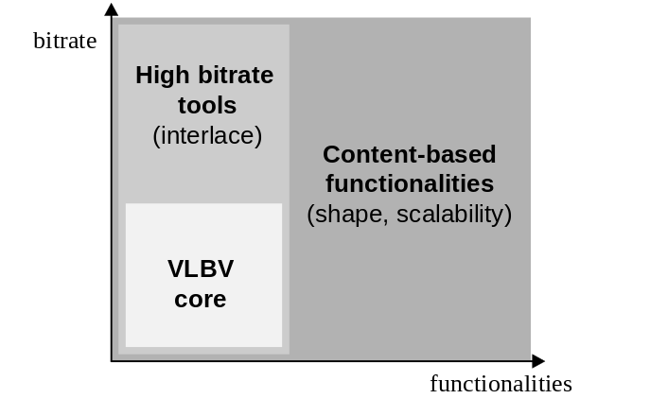
Figure 8 - Classification of the MPEG-4 Image and Video Coding Algorithms and Tools

At the bottom end a “VLBV Core” (VLBV: Very Low Bit-rate Video) provides algorithms and tools for applications operating at bit-rates typically between 5...64 kbits/s, supporting image sequences with low spatial resolution (typically up to CIF resolution) and low frame rates (typically up to 15 Hz). The basic applications specific functionalities supported by the VLBV Core include:

a) VLBV coding of conventional rectangular size image sequences with high coding efficiency and high error robustness/resilience, low latency and low complexity for real-time multimedia communications applications, and

b) provisions for “random access” and “fast forward” and “fast reverse” operations for VLB multimedia data-base storage and access applications.

The same basic functionalities outlined above are also supported at higher bit-rates with a higher range of spatial and temporal input parameters up to ITU-R Rec. 601 resolutions - employing identical or similar algorithms and tools as the VLBV Core. The bit-rates envisioned range typically from 64 kbits/s up to 4 Mb/s and applications envisioned include broadcast or interactive retrieval of signals with a quality comparable to digital TV. For these applications at higher bit-rates, tools for coding interlaced signals are specified in MPEG-4.

Content-based functionalities support the separate encoding and decoding of content (i.e. physical objects in a scene, VOs). This MPEG-4 feature provides the most elementary mechanism for interactivity; flexible representation and manipulation with/of VO content of images or video in the compressed domain, without the need for further segmentation or transcoding at the receiver.

For the hybrid coding of natural as well as synthetic visual data (e.g. for virtual presence or virtual environments) the content-based coding functionality allows mixing a number of VO's from different sources with synthetic objects, such as a virtual background.

The extended MPEG-4 algorithms and tools for content-based functionalities can be seen as a superset of the VLBV core and high bit-rate tools - meaning that the tools provided by the VLBV and HBV Cores are complemented by additional elements.

Support for Conventional and Content-Based Functionalities
The MPEG-4 Video standard will support the decoding of conventional rectangular images and video as well as the decoding of images and video of arbitrary shape. This concept is illustrated in Figure 9 below.

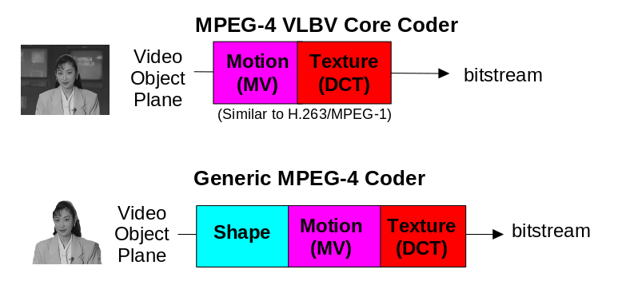
Figure 9 - the VLBV Core and the Generic MPEG-4 Coder

The coding of conventional images and video is achieved similar to conventional MPEG-1/2 coding and involves motion prediction/compensation followed by texture coding. For the content-based functionalities, where the image sequence input may be of arbitrary shape and location, this approach is extended by also coding shape and transparency information. Shape may be either represented by an 8 bit transparency component - which allows the description of transparency if one VO is composed with other objects - or by a binary mask.

The extended MPEG-4 content-based approach can be seen as a logical extension of the conventional MPEG-4 VLBV Core or high bit-rate tools towards input of arbitrary shape.

The MPEG-4 Video Image and Coding Scheme
Figure 10 below outlines the basic approach of the MPEG-4 video algorithms to encode rectangular as well as arbitrarily shaped input image sequences.

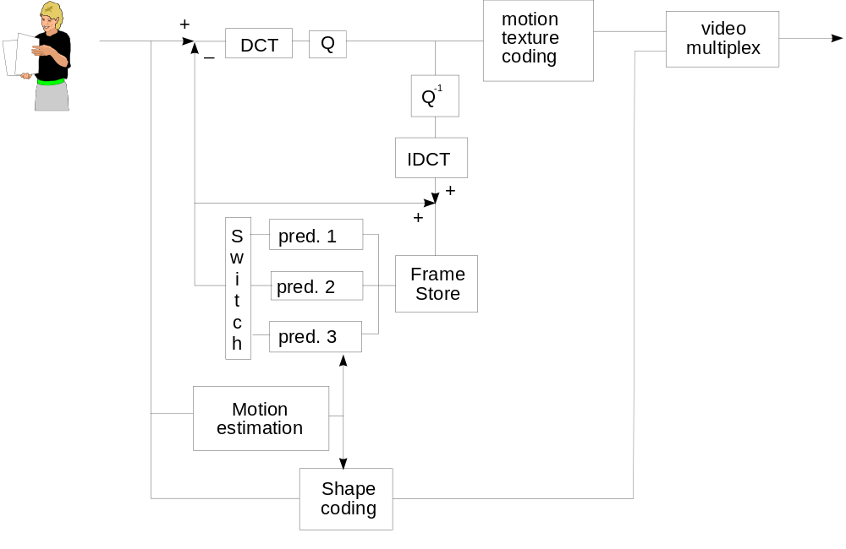

Figure 10 - Basic block diagram of MPEG-4 Video Coder

The basic coding structure involves shape coding (for arbitrarily shaped VOs) and motion compensation as well as DCT-based texture coding (using standard 8x8 DCT or shape adaptive DCT).

An important advantage of the content-based coding approach taken by MPEG-4, is that the compression efficiency can be significantly improved for some video sequences by using appropriate and dedicated object-based motion prediction “tools” for each object in a scene. A number of motion prediction techniques can be used to allow efficient coding and flexible presentation of the objects:

- Standard 8x8 or 16x16 pixel block-based motion estimation and compensation.
- Global motion compensation using 8 motion parameters that describe an affine transformation.
- Global motion compensation based on the transmission of a static “sprite”. A static sprite is a possibly large still image, describing panoramic background. For each consecutive image in a sequence, only 8 global motion parameters describing camera motion are coded to reconstruct the object. These parameters represent the appropriate affine transform of the sprite transmitted in the first frame.
- Global motion compensation based on dynamic sprites. Sprites are not transmitted with the first frame but dynamically generated over the scene.

Coding of Textures and Still Images
Efficient Coding of visual textures and still images is supported by the visual texture mode of the MPEG-4. This mode is based on a zerotree wavelet algorithm that provides very high coding efficiency at very wide range of bitrates. Together with high compression efficiency, it also provides spatial and quality scalabilities (up to 11 levels of spatial scalability and continuos quality scalability) and also arbitrary-shaped object coding.

Scalable Coding of Video Objects
MPEG-4 supports the coding of images and video objects with spatial and temporal scalability, both with conventional rectangular as well as with arbitrary shape. Scalability refers to the ability to only decode a part of a bit stream and reconstruct images or image sequences with:
- reduced decoder complexity and thus reduced quality
- reduced spatial resolution
- reduced temporal resolution
- with equal temporal and spatial resolution but with reduced quality.

This functionality is desired for progressive coding of images and video over heterogeneous networks, as well as for applications where the receiver is not willing or capable of displaying the full resolution or full quality images or video sequences. This could for instance happen when processing power or display resolution is limited.

For decoding of still images, the MPEG-4 standard will provide spatial scalability with up to 11 levels of granularity and also quality scalability up to the bit level. For video sequences a maximum of 3 levels of granularity will be supported.

Robustness in Error Prone Environments
MPEG-4 provides error robustness and resilience to allow accessing image or video information over a wide range of storage and transmission media. In particular, due to the rapid growth of mobile communications, it is extremely important that access is available to audio and video information via wireless networks. This implies a need for useful operation of audio and video compression algorithms in error-prone environments at low bit-rates (i.e., less than 64 Kbps).

The error resilience tools developed for MPEG-4 can be divided into three major areas. These areas or categories include resynchronization, data recovery, and error concealment. It should be noted that these categories are not unique to MPEG-4, but instead have been used by many researchers working in the area error resilience for video. It is, however, the tools contained in these categories that are of interest, and where MPEG-4 makes its contribution to the problem of error resilience.

Resynchronization
Resynchronization tools, as the name implies, attempt to enable resynchronization between the decoder and the bitstream after a residual error or errors have been detected. Generally, the data between the synchronization point prior to the error and the first point where synchronization is reestablished, is discarded. If the resynchronization approach is effective at localizing the amount of data discarded by the decoder, then the ability of other types of tools which recover data and/or conceal the effects of errors is greatly enhanced.

The resynchronization approach adopted by MPEG-4, referred to as a packet approach, is similar to the Group of Blocks (GOBs) structure utilized by the ITU-T standards of H.261 and H.263. In these standards a GOB is defined as one or more rows of macroblocks (MBs). At the start of a new GOB, information called a GOB header is placed within the bitstream. This header information contains a GOB start code, which is different from a picture start code, and allows the decoder to locate this GOB. Furthermore, the GOB header contains information which allows the decoding process to be restarted (i.e., resynchronize the decoder to the bitstream and reset all predictively coded data).
The GOB approach to resynchronization is based on spatial resynchronization. That is, once a particular macroblock location is reached in the encoding process, a resynchronization marker is inserted into the bitstream. A potential problem with this approach is that since the encoding process is variable rate, these resynchronization markers will most likely be unevenly spaced throughout the bitstream. Therefore, certain portions of the scene, such as high motion areas, will be more susceptible to errors, which will also be more difficult to conceal.

The video packet approach adopted by MPEG-4, is based on providing periodic resynchronization markers throughout the bitstream. In other words, the length of the video packets are not based on the number of macroblocks, but instead on the number of bits contained in that packet. If the number of bits contained in the current video packet exceeds a predetermined threshold, then a new video packet is created at the start of the next macroblock.

A resynchronization marker is used to distinguished the start of a new video packet. This marker is distinguishable from all possible VLC codewords as well as the VOP start code. Header information is also provided at the start of a video packet. Contained in this header is the information necessary to restart the decoding process and includes: the macroblock number of the first macroblock contained in this packet and the quantization parameter necessary to decode that first macroblock. The macroblock number provides the necessary spatial resynchronization while the quantization parameter allows the differential decoding process to be resynchronized.

Also included in the video packet header is the header extension code. The HEC is a single bit that, when enabled, indicates the presence of additional resynchronization information; including modular time base, VOP temporal increment, VOP prediction type, and VOP F code. This additional information is made available in case the VOP header has been corrupted.

It should be noted that when utilizing the error resilience tools within MPEG-4, some of the compression efficiency tools are modified. For example, all predictively encoded information must be confined within a video packet so as to prevent the propagation of errors.

In conjunction with the video packet approach to resynchronization, a second method called fixed interval synchronization has also been adopted by MPEG-4. This method requires that VOP start codes and resynchronization markers (i.e., the start of a video packet) appear only at legal fixed interval locations in the bitstream. This helps to avoid the problems associated with start codes emulations. That is, when errors are present in a bitstream it is possible for these errors to emulate a VOP start code. In this case, when fixed interval synchronization is utilized the decoder is only required to search for a VOP start code at the beginning of each fixed interval. The fixed interval synchronization method extends this approach to be any predetermined interval.

Data Recovery
After synchronization has been reestablished, data recovery tools attempt to recover data that in general would be lost. These tools are not simply error correcting codes, but instead techniques which encode the data in an error resilient manner. For instance, one particular tool that has been endorsed by the Video Group is Reversible Variable Length Codes (RVLC). In this approach, the variable length codewords are designed such that they can be read both in the forward as well as the reverse direction.

An example illustrating the use of a RVLC is given in Figure 11. Generally, in a situation such as this, where a burst of errors has corrupted a portion of the data, all data between the two synchronization points would be lost. However, as shown in the Figure, an RVLC enables some of that data to be recovered. It should be noted that the parameters, QP and HEC shown in the Figure, represent the fields reserved in the video packet header for the quantization parameter and the header extension code, respectively.

Error Concealment
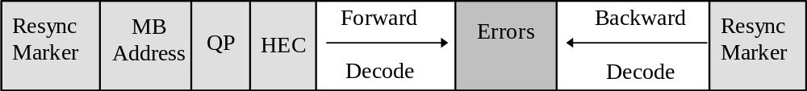
Figure 11 - example of Reversible Variable Length Code
Error concealment is an extremely important component of any error robust video codec. Similar to the error resilience tools discussed above, the effectiveness of an error concealment strategy is highly dependent on the performance of the resynchronization scheme. Basically, if the resynchronization method can effectively localize the error then the error concealment problem becomes much more tractable. For low bitrate, low delay applications the current resynchronization scheme provides very acceptable results with a simple concealment strategy, such as copying blocks from the previous frame.

In recognizing the need to provide enhanced concealment capabilities, the Video Group has developed an additional error resilient mode that further improves the ability of the decoder to localize an error.
Specifically, this approach utilizes data partitioning by separating the motion and the texture. This approach requires that a second resynchronization marker be inserted between motion and texture information. If the texture information is lost, this approach utilizes the motion information to conceal these errors. That is, due to the errors the texture information is discarded, while the motion is used to motion compensate the previous decoded VOP.

Scene description
In addition to providing support for coding individual objects, MPEG-4 also provides facilities to compose a set of such objects into a scene. The necessary composition information forms the scene description, which is coded and transmitted together with the AV objects.

In order to facilitate the development of authoring, manipulation and interaction tools, scene descriptions are coded independently from streams related to primitive AV objects. Special care is devoted to the identification of the parameters belonging to the scene description. This is done by differentiating parameters that are used to improve the coding efficiency of an object (e.g., motion vectors in video coding algorithms), and the ones that are used as modifiers of an object (e.g., the position of the object in the scene). Since MPEG-4 should allow the modification of this latter set of parameters without having to decode the primitive AVOs themselves, these parameters are placed in the scene description and not in primitive AV objects.

The following list gives some examples of the information described in a scene description.

How objects are grouped together: An MPEG-4 scene follows a hierarchical structure which can be represented as a directed acyclic graph. Each node of the graph is an AV object, as illustrated in Figure 12 (note that this tree refers back to Figure 1). The tree structure is not necessarily static; node attributes (e.g., positioning parameters) can be changed while nodes can be added, replaced, or removed.

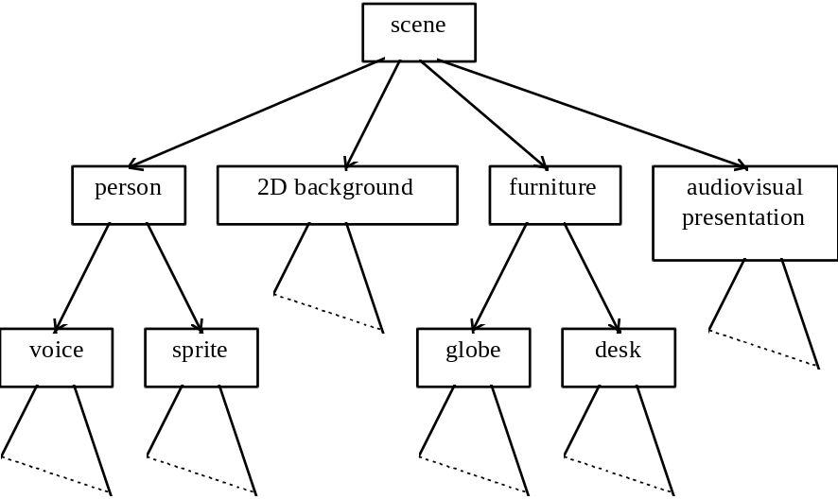

Figure 12- Logical structure of a scene

How objects are positioned in space and time: In the MPEG-4 model, audiovisual objects have both a spatial and a temporal extent. Each AV object has a local coordinate system. A local coordinate system for an object is one in which the object has a fixed spatio-temporal location and scale. The local coordinate system serves as a handle for manipulating the AV object in space and time. AV objects are positioned in a scene by specifying a coordinate transformation from the object’s local coordinate system into a global coordinate system defined by one more parent scene description nodes in the tree.

Attribute Value Selection: Individual AV objects and scene description nodes expose a set of parameters to the composition layer through which part of their behavior can be controlled. Examples include the pitch of a sound, the color for a synthetic object, activation or deactivation of enhancement information for scaleable coding, etc.

Other transforms on AVOs: The scene description structure and node semantics are heavily influenced by VRML, including its event model. This provides MPEG-4 with a very rich set of scene construction operators, including graphics primitives, that can be used to construct sophisticated scenes.

User interaction
MPEG-4 allows for user interaction with the presented content. This interaction can be separated into two major categories: client-side interaction and server-side interaction. Client-side interaction involves content manipulation which is handled locally at the end-user’s terminal, and can take several forms. In particular, the modification of an attribute of a scene description node, e.g., changing the position of an object, making it visible or invisible, changing the font size of a synthetic text node, etc., can be implemented by translating user events (e.g., mouse clicks or keyboard commands) to scene description updates. The commands can be processed by the MPEG-4 terminal in exactly the same way as if they originated from the original content source. As a result, this type of interaction does not require standardization.

Other forms of client-side interaction require support from the scene description syntax, and are specified by the standard. The use of the VRML event structure provides a rich model on which content developers can create compelling interactive content.

Server-side interaction involves content manipulation that occurs at the transmitting end, initiated by a user action. This, of course, requires that a back-channel is available.

Content-related IPR identification and protection
MPEG-4 provides mechanisms for protection of intellectual property rights (IPR), as outlined in section 1.5. This is achieved by supplementing the coded AVOs with an optional Intellectual Property Identification (IPI) data set, carrying information about the contents, type of content and (pointers to) rights holders. The data set, if present, is in the stream header, which is linked to objects or scene description (and linked to the AVOs), or in the AVOs themselves. The number of data sets to be associated with each AVO is flexible; different AVOs can share the same data sets or have separate data sets. The provision of the data sets allows the implementation of mechanisms for audit trail, monitoring, billing, and copy protection.

Object Content Information
MPEG-4 will allow attaching information to objects about their content. Users of the standard can use this ‘OCI’ datastream to send textual information along with MPEG-4 content. It is also possible to classify content according to pre-defined tables, which will be defined outside of MPEG.

List of major functionalities provided by MPEG-4 in January ’99
This section contains, in an itemized fashion, the major functionalities that the different parts of the MPEG-4 Standard will offer.

DMIF
DMIF supports the following functionalities:
- A transparent MPEG-4 DMIF-application interface irrespective of whether the peer is a remote interactive peer, broadcast or local storage media.
- Control of the establishment of FlexMux channels
- Use of homogeneous networks between interactive peers: IP, ATM, mobile, PSTN, Narrowband ISDN.

Systems
- Scene description for composition (spatio-temporal synchronization with time response behavior) of multiple AV objects. The scene description provides a rich set of nodes for 2D and 3D composition operators and graphics primitives.
- Text with international language support, font and font style selection, timing and synchronization.
- Interactivity, including: client and server-based interaction; a general event model for triggering events or routing user actions; general event handling and routing between objects in the scene, upon user or scene triggered events.
- The interleaving of multiple streams into a single stream, including timing information (multiplexing).
- Transport layer independence. Through the separation of the multiplexing operation into FlexMux and TransMux, support for a large variety of transport facilities is achieved.
- The initialization and continuous management of the receiving terminal’s buffers:
- Timing identification, synchronization and recovery mechanisms.
- Datasets covering identification of Intellectual Property Rights relating to Audiovisual Objects.

Audio
A number of functionality’s are provided to facilitate a wide variety of applications which could range from intelligible speech to high quality multichannel audio, and from natural sounds to synthesized sounds. MPEG-4 Audio supports the highly efficient representation of audio objects consisting of
- Speech signals: Speech coding can be done using bitrates from 2 kbit/s up to 24 kbit/s using the speech coding tools. Low delay is possible for communications applications.
- Synthesized Speech: Hybrid Scaleable TTS allows a text, or a text with prosodic parameters (pitch contour, phoneme duration, and so on), as its inputs to generate intelligible synthetic speech.
- Facial animation control with Lip Shape Patterns or with phoneme information.
- Phoneme string with duration information generation for phoneme-to-FAP converter
- Motion picture dubbing with lip shape patterns
- Trick mode functionality: pause, resume, jump forward/backward.
- International language support for text.
- International symbol support for phonemes.
- Low bandwidth generic audio signals: This functionality provides for music and speech representation for severely bandwidth-limited channels like Internet audio. It is available via the T/F-based coding tools.
- High bandwidth generic audio signals: Support for coding generic audio hat high quality is provided by T/F-based decoders. With this functionally, broadcast quality audio from mono up to multichannel representation is available.
- Synthesized Audio: Synthetic Audio support is provided by a Structured Audio Decoder implementation that allows the application of score-based control information to musical instruments described in a special language.
- Bounded-complexity Synthetic Audio: This is provided by a Structured Audio Decoder implementation that allows the processing of a standardized wavetable format.

Examples of additional functionality’s are speed control, pitch change, error resilience and scalability in terms of bitrate, bandwidth, error robustness, complexity, etc. as defined below.
- The speed change functionality allows the change of the time scale without altering the pitch during the decoding process. This can, for example, be used to implement a “fast forward” function (data base search) or to adapt the length of an audio sequence to a given video sequence, or for practicing dance steps at slower play back speed.
- The pitch change functionality allows the change of the pitch without altering the time scale during the encoding or decoding process. This can be used, for example, for voice alteration or Karaoke type applications. This technique only applies to parametric and structured audio coding methods.
- Bitrate scalability allows a bitstream to be parsed into a bitstream of lower bitrate such that the combination can still be decoded into a meaningful signal. The bit stream parsing can occur either during transmission or in the decoder.
- Bandwidth scalability is a particular case of bitrate scalability, whereby part of a bitstream representing a part of the frequency spectrum can be discarded during transmission or decoding.
- Encoder complexity scalability allows encoders of different complexity to generate valid and meaningful bitstreams.
- Decoder complexity scalability allows a given bitstream to be decoded by decoders of different levels of complexity. The audio quality, in general, is related to the complexity of the encoder and decoder used.
- Error robustness provides the ability for a decoder to avoid or conceal audible distortion caused by transmission errors.
- Audio Effects provide the ability to process decoded audio signals with complete timing accuracy to achieve functions for mixing , reverberation, spatialization, etc.

Visual
The MPEG-4 Visual standard will allow the hybrid coding of natural (pixel based) images and video together with synthetic (computer generated) scenes. This will, for example, allow the virtual presence of videoconferencing participants. To this end, the Visual standard will comprise tools and algorithms supporting the coding of natural (pixel based) still images and video sequences as well as tools to support the compression of synthetic 2-D and 3-D graphic geometry parameters (i.e. compression of wire grid parameters, synthetic text).
The subsections below give an itemized overview of functionalities that the tools and algorithms of the MPEG-4 visual standard will support.

Formats Supported
The following formats and bitrates will be supported:
- bitrates: typically between 5 kbit/s and 4 Mbit/s
- Formats: progressive as well as interlaced video
- Resolutions: typically from sub-QCIF to TV

Compression Efficiency
- Efficient compression of video will be supported for all bit rates addressed. This includes the compact coding of textures with a quality adjustable between "acceptable" for very high compression ratios up to "near lossless".
- Efficient compression of textures for texture mapping on 2-D and 3-D meshes.
- Random access of video to allow functionalities such as pause, fast forward and fast reverse of stored video.

Content-Based Functionalities
- Content-based coding of images and video to allow separate decoding and reconstruction of arbitrarily shaped video objects.
- Random access of content in video sequences to allow functionalities such as pause, fast forward and fast reverse of stored video objects.
- Extended manipulation of content in video sequences to allow functionalities such as warping of synthetic or natural text, textures, image and video overlays on reconstructed video content. An example is the mapping of text in front of a moving video object where the text moves coherently with the object.

Scalability of Textures, Images and Video
- Complexity scalability in the encoder allows encoders of different complexity to generate valid and meaningful bitstreams for a given texture, image or video.
- Complexity scalability in the decoder allows a given texture, image or video bitstream to be decoded by decoders of different levels of complexity. The reconstructed quality, in general, is related to the complexity of the decoder used. This may entail that less powerful decoders decode only a part of the bitstream.
- Spatial scalability allows decoders to decode a subset of the total bit stream generated by the encoder to reconstruct and display textures, images and video objects at reduced spatial resolution. For textures and still images, a maximum of 11 levels of spatial scalability will be supported. For video sequences, a maximum of three levels will be supported.
- Temporal scalability allows decoders to decode a subset of the total bit stream generated by the encoder to reconstruct and display video at reduced temporal resolution. A maximum of three levels will be supported.
- Quality scalability allows a bitstream to be parsed into a number of bit stream layers of different bitrate such that the combination of a subset of the layers can still be decoded into a meaningful signal. The bit stream parsing can occur either during transmission or in the decoder. The reconstructed quality, in general, is related to the number of layers used for decoding and reconstruction.

Shape and Alpha Channel Coding
- Shape coding will be supported to assist the description and composition of conventional images and video as well as arbitrarily shaped video objects. Applications that benefit from binary shape maps with images are content based image representations for image data bases, interactive games, surveillance, and animation. Efficient techniques are provided that allow efficient coding of binary shape. A binary alpha map defines whether or not a pixel belongs to an object. It can be ‘on’ or ‘off’.

Robustness in Error Prone Environments
- Error resilience will be supported to assist the access of image and video over a wide range of storage and transmission media. This includes the useful operation of image and video compression algorithms in error-prone environments at low bit-rates (i.e., less than 64 Kbps). Tools are provided which address both the band limited nature and error resiliency aspects for access over wireless networks.

Face Animation
The ‘Face Animation’ part of the standard allow sending parameters that calibrate and animate synthetic faces. These models themselves are not standardized by MPEG-4, only the parameters are.
- Definition and coding of face animation parameters (model independent):
- Feature point positions and orientations to animate the face definition meshes
- Visemes, or visual lip configurations equivalent to speech phonemes
- Definition and coding of face definition parameters (for model calibration):
- 3D feature point positions
- 3D head calibration meshes for animation
- Texture map of face
- Personal characteristics
- Facial texture coding;

Coding of 2D Meshes with Implicit Structure
- Mesh-based prediction and animated texture transfiguration
- 2D Delaunay mesh formalism with motion tracking of animated objects
- Motion prediction and suspended texture transmission with dynamic meshes.
- Geometry compression:
- 2D mesh compression with implicit structure & decoder reconstruction

Profiles in MPEG-4 Version 1

Introduction to Profiles
For DMIF and Systems, MPEG-4 has ‘Profiles’: subset of the complete toolbox that enable a large class of applications. For Audio and Visual, MPEG-4 also has Profiles, but here a distinction is made between Object Profiles and Composition Profiles:
- Object Profiles define the syntax and tools for a single (Audio of Visual) Object;
- Composition Profiles are meant to determine which Objects can be combined in a decoder, and how (e.g. a Texture object can be mapped to a Mesh object). The definition of Composition Profiles references Object Profiles.

The Composition Profiles are defined for Audio and Visual separately, as MPEG does not want to prescribe how to combine Audio and Visual tools. Thus, no Audio-Visual (Composition) Profiles exist.
Composition Profiles still give no bounds on things like bitrate, complexity, screen size, sampling rate, etc. These constraints are to be defined in the Composition Profile’s Levels. No Levels have been defined yet.

The Sections that follow list the Profiles according to the MPEG Groups that build the tools.

DMIF
The DMIF tools contained in the DMIF Profile specifications cover the following aspects:
- DMIF-Application Interface (DAI)
- Designed for application transparency to MPEG-4 content location and access
- Designed for packing MPEG-4 Elementary Streams on network transports based on QoS considerations
- DMIF-DMIF Interface (DDI) – To ensure end-to-end QoS based on preserving the user view at each DMIF end-system involved in an MPEG-4 session.
These tools are subdivided into profiles according to their use to different applications, as follows in the next three subsections.

Profile 1: Broadcast DMIF Profile
- DAI is used to access MPEG-4 content transparently over different Broadcast media
- DAI accommodates different content packing to suite the individual media Broadcast standard used

Profile 2: Broadcast and storage DMIF Profile
- DAI is used in addition to Profile 1 to:
- Access local Stored Files using MPEG-4 File Formats on different storage media
- Record on local storage using MPEG-4 File Formats
- DAI is used to in addition to Profile 1 to:
- Content packing to suite individual multimedia storage format standards

Profile 3: Broadcast, storage and Remote Interactive DMIF Profile
Level 1
- DAI is used in addition to Profile 2 to:
- Access remote interactive DMIF end-systems on a best effort basis
- Access remote storage files on DMIF end-systems on a best effort basis
- Accommodates access through different transport media on a single network
- DAI is used in addition to Profile 2 for:
- Content packing to suite individual network transport format standards
- DDI relies on networks to log individual connections without managing resources within a session

Level 2
- DAI is used in addition to Profile 2 to:
- Access remote interactive DMIF end-systems with an end-user agreed and content author defined level of QoS;
- Access remote storage files on DMIF end-systems with an end-user agreed and content author defined level of QoS;
- Accommodates access through different transport media consisting of multiple access and backbone networks.
- DAI is used in addition to Profile 2 for:
- Content packing to suite individual network transport format standards while preserving individual DMIF end-system views
- DDI network based Session and Resource Management functions to manage and log usage of network resources within a session

Systems
Systems Profiles are defined that restrict the capabilities in the area of the allowed transforms in the compositor. These transforms correspond to BIFS nodes. Nodes are organized into Shared, 2D, 3D, Mixed. The profiles are defined in terms of these sets of nodes, when possible.

2D profile
Applications supporting only 2D graphics capabilities have to conform to the “2D profile” as specified in this Section. This is intended for systems that implement low complexity graphics with 2D transformations and alpha blending.

3D profile
Applications supporting the complete set of 3D capabilities have to conform to the “3D profile” as specified in this Section. This profile addresses systems that implement a full 3D graphics system, which requires much higher implementation complexity than the “2D profile”.
Note that the “3D profile” is a 3D only profile, which is not a superset of 2D; the 2D nodes which are not Shared nodes are not included in the 3D profile.

VRML profile
Applications claiming conformance with the “VRML profile” of this Committee Draft have to implement all and only the nodes specified by this International Standard, that are common to the specification of Draft International Standard 14472-1 (VRML). The intention of this Profile is to maximize the interoperability between MPEG-4 and VRML.

Complete profile
Applications supporting the complete set of capabilities specified by this Part 1 of the Systems Committee Draft conform to the “Complete Profile”.

Audio profile
Applications supporting all and only the audio related nodes as defined by this Section conform to the “Systems Audio Profile”. This Profile is meant for Audio-only applications.

Audio
This section contains the object profiles for natural audio, synthetic audio, and text to speech (TTS). It also includes a section outline the current agreements on audio composition profiles.

Object Profiles: Natural Audio

Profile | Hierarchy info | Tools
Main | contains simple scalable | - all natural audio tools  - all speech audio tools  - syntax for scalability
- Simple scalable | contains natural speech  - CELP based  - Parameter based | - CELP tool  - 13818-7 LC profile  - 13818-7 SSR profile  - AAC with PNS and LTP  - scalable CELP/AAC  - other t/f tools dependent on tests
 |  | - 13818-7 all tools
- Simple Parametric Audio |  | - HILN  - HVXC
Note: 13818-7 is MPEG-2 AAC (Advanced Audio Coding)

Synthetic audio Object Profiles

Profile | Hierarchy info | Tools
Main | contains all others | - all structured audio tools
- Algorithmic synthesis | contains syntax of General MIDI | - SAOL  - SASL  - MIDI
- Wavetable synthesis | contains syntax of General MIDI | - SASBF  - MIDI
- General MIDI | no | - MIDI

Text-to-Speech Object Profiles
Profile | Hierarchy information | Tools
TTS | no | - TTS interface:

Audio Composition Profiles
The following Audio Composition Profiles have been defined:

Profile | Hierarchy information | Object profiles contained
Main | contains simple | - main natural audio  - structured audio  - TTS interface  - composition (number and type dependent on level)
- Simple | contains speech | - simple scalable audio  - algorithmic synthesis  - simple with level 1 scene description
- Speech |  | - Parameter-based speech coding  - CELP-based speech coding

Visual Object Profiles
.
The first Object Profile has been named the Simple Object Profile. The second Object Profile has been named the Core Object Profile. These two are hierarchical, Core encompassing Simple. There is also a ’12 bit’ Video Object Profile, that is the Simple Object Profile, to which tools for the coding of 4-12 bits pixel depth video have been added. Lastly, an Object Profile has been defined for the coding of scaleable textures.
The following sections list the tools for each of the Object Profiles:

Simple Video Object Profile
The tools used to build the Simple Video Object Profile are:
- Intra mode (I)
- Predicted mode (P)
- AC/DC prediction
- Slice resynchronization
- Reversible Variable Length Code tables
- Data partitioning
- Binary Shape with Uniform Transparency
- P-VOP based arbitrary shape temporal scalability with rectangular base layer

Note: In the unlikely case that the error resilience tools cannot interwork with the binary shape tool and/or the temporal scalability tool, a revision of the Object Profile may be necessary.

12 bit Video Object Profile
The 12 bit Video Object Profile is identical to the Simple Profile, with one tool added:
- coding of video with 4-12 bits pixel depth

Core Video Object Profile
The next profile under consideration, with the working name ‘Core’, includes the following tools:
- All the tools for Simple
- Bi-directional prediction mode (B)
- H.263/MPEG-2 Quantization Tables
- Overlapped Block Motion Compensation
- Unrestricted Motion Vectors
- Four Motion Vectors per Macroblock
- Static Sprites
- temporal scalability
- frame-based
- object-based
- spatial scalability (frame-based)
- Tools for coding of interlaced video

Scalable Image Texture Object Profile
- Scalable Wavelets
- Binary Shape
An overview of the of the Visual Object Profiles looks as follows:
Figure 13- Overview of Visual Object Profiles
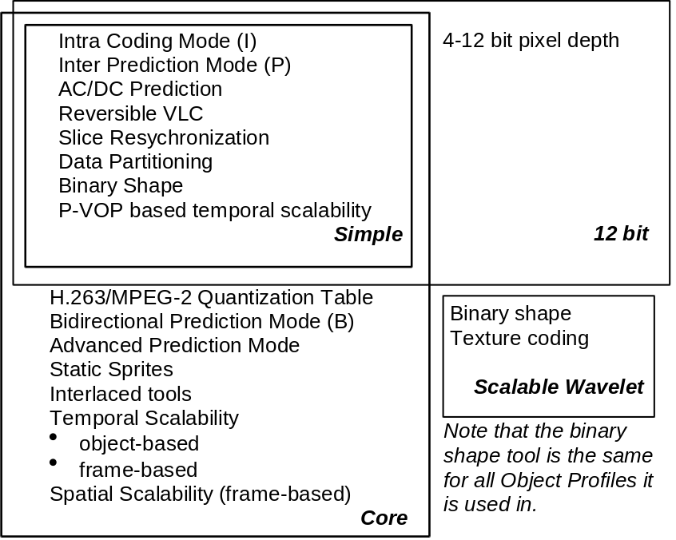

SNHC

Object Profile for Face Animation – Simple Profile
Roughly speaking, the Simple Facial Animation Object Profile only requires the Facial and Body Animation (FBA) decoder to properly displace or rotate the appropriate 3D feature points for which FAPs (Facial Animation Parameters) have been received. If only FAP data has been received (no Facial Definition Parameter - FDP - data received) the feature points are located on the local face model which is not known to the encoder. All FDP data (feature points, mesh, texture or FAT) may be ignored by the face decoder in this profile.

Object Profile for Face Animation – Advanced Profile
The Predictable Facial Animation Object Profile assumes all Simple Profile requirements. In addition, the decoder must decode and use all the other information that it receives.

Annexes
Annex A - The MPEG-4 development process
The Moving Picture Coding Experts Group (MPEG) is a working group of ISO/IEC in charge of the development of international standards for compression, decompression, processing, and coded representation of moving pictures, audio and their combination.
The purpose of MPEG is to produce standards. The first two standards produced by MPEG were:
- MPEG-1, a standard for storage and retrieval of moving pictures and audio on storage media (officially designated as ISO/IEC 11172, in 5 parts)
- MPEG-2, a standard for digital television (officially designated as ISO/IEC 13818, in 9 parts).
MPEG is now working to produce MPEG-4, a standard for multimedia applications, scheduled for completion in January 1999 with the ISO number 14496. MPEG has also just started work on a new standard known as MPEG-7: a content representation standard for information search, scheduled for completion in January 2001.
MPEG-1 has been a very successful standard. It is the de-facto form of storing moving pictures and audio on the World Wide Web and is used in millions of Video CDs. Digital Audio Broadcasting (DAB) is a new consumer market that makes use of MPEG-1 audio coding.
MPEG-2 has been the timely response for the satellite broadcasting and cable television industries in their transition from analogue to digital. Millions of set-top boxes incorporating MPEG-2 decoders have been sold in the last 3 years.
Since July 1993 MPEG is working on its third standard, called MPEG-4. MPEG considers of vital importance to define and maintain, without slippage, a work plan. This is the MPEG-4 work plan:
Table 1 - MPEG-4 work plan

Part | Title | WD | CD | FCD | DIS | IS
1 | Systems |  | 97/11 | 98/07 | 98/11 | 99/01
2 | Visual |  | 97/11 | 98/07 | 98/11 | 99/01
3 | Audio |  | 97/11 | 98/07 | 98/11 | 99/01
4 | Conformance Testing | 97/10 | 98/11 | 99/07 | 99/11 | 00/01
5 | Reference Software |  | 97/11 | 98/07 | 98/11 | 99/01
6 | Delivery Multimedia Integration Framework (DMIF) | 97/07 | 97/11 | 98/07 | 98/11 | 99/01
(NB: The abbreviations are explained below)

Because of the complexity of the work item, it took 2 years before a satisfactory definition of the scope could be achieved and 2½ years before a first call for proposals could be issued. This call, like all MPEG calls, was open to all interested parties, no matter whether they were within or outside of MPEG. It requested technology that proponents felt could be considered by MPEG for the purpose of the developing the MPEG-4 standard. After that first call, other calls were issued for other technology areas.
The proposals of technology received were assessed and, if found promising, incorporated in the so-called Verification Models (VMs). A VM describes, in text and some sort of programming language, the operation of encoder and decoder. VMs are used to carry out simulations with the
aim to optimize the performance of the coding schemes.
Because – next to the envisaged hardware environments for MPEG-4 – software platforms are gaining in importance for multimedia standards, MPEG decided to maintain software implementations of the different standard parts. These can be used for the purpose of development of the standard and for commercial implementations of the standard. At the Maceió meeting in November ’96 MPEG reached sufficient confidence in the stability of the standard under development, and produced the Working Drafts (WDs). Much work has been done since, resulting in the production of Committee Drafts.
The WDs already had the structure and form of a standard but they were kept internal to MPEG for revision. Starting from the Sevilla meeting in February ’97, MPEG decided to publish the WDs to seek first comments from industry. In October ’97, the WDs became Committee Drafts (CD) and were sent to National Bodies (NB) for ballot. Currently there are 5 CDs:

Part 1 | Systems CD | 0.1
Part 2 | Visual CD | 0.1
Part 3 | Audio CD | 0.1
Part 4 | Conformance WD | 1.0
Part 5 | Reference Software CD | 0.1
Part 6 | DMIF CD | 0.1

Ballots by NBs are usually accompanied by technical comments. These ballots will be considered at the March ’98 meeting in Tokyo. If the number of positive votes is more than 2/3 of the total, the CDs will become Final CDs or FCDs (this process is likely to entail a number of technical changes to accommodate NB comments).
The FCDs will be sent again to the National Bodies for a second ballot, the outcome of which will be considered at the November ’98 meeting in Israel with a similar process as for the CD stage. In November ’98, MPEG-4 will become Draft International Standard (DIS). It will then be sent to National Bodies for a final ballot where NB are only allowed to cast a yes/no ballot without comments. If the number of positive votes is above 3/4, the DIS will become International Standard (IS) and is sent to the ISO Central Secretariat for publication.
Annex B - Organization of work in MPEG
Established in 1988, MPEG has grown to form an unusually large committee. Some 300 experts take part in MPEG meetings, and the number of people working on MPEG-related matters without attending meetings is even larger.
The wide scope of technologies considered by MPEG and the large expertise available require an appropriate organization. Currently MPEG has the following subgroups:

- Requirements | develops requirements for the standards under development (currently, MPEG-4 and MPEG-7).
- DSM  (Digital Storage Media) | develops standards for interfaces between DSM servers and clients for the purpose managing DSM resources, and controlling the delivery of MPEG bitstreams and associated data.
- Delivery | develops standards for interfaces between MPEG-4 applications and peers or broadcast media, for the purpose of managing transport resources.
- Systems | develops standards for the coding of the combination of individually coded audio, moving images and related information so that the combination can be used by any application.
- Video | develops standards for coded representation of moving pictures of natural origin.
- Audio | develops standards for coded representation of audio of natural origin.
- SNHC  (Synthetic- Natural Hybrid Coding) | develops standards for the integrated coded representation of audio and moving pictures of natural and synthetic origin. SNHC concentrates on the coding of synthetic data.
- Test | develops methods for and the execution of subjective evaluation tests of the quality of coded audio and moving pictures, both individually and combined, to test the quality of moving pictures and audio produced by MPEG standards
- Implementation | evaluates coding techniques so as to provide guidelines to other groups upon realistic boundaries of implementation parameters.
- Liaison | handles relations with bodies external to MPEG.
- HoD  Heads of Delegation | : the group acts in advisory capacity on matters of general nature.

Work for MPEG takes place in two different instances. A large part of the technical work is done at MPEG meetings, usually lasting one full week. Members electronically submit contributions to the MPEG FTP site (several hundreds of them at every meeting). Delegates are then able to come to meetings well prepared without having to spend precious meeting time to study other delegates' contributions.
The meeting is structured in 3 Plenary meetings (on Monday morning, on Wednesday morning and on Friday afternoon) and in parallel subgroup meetings.
About 100 output documents are produced at every meeting; these capture the agreements reached. Documents of particular importance are:
- “Resolutions”, which document the outline of each agreement and make reference to the documents produced;
- “Ad-hoc groups”, groups of delegates agreeing to work on specified issues, usually until the following meeting;
- Drafts of the different parts of the standard under development;
- New versions of the different Verification Models, that are used to develop the respective parts of the standard.

Output documents are also stored on the MPEG FTP site. Access to input and output documents is restricted to MPEG members. At each meeting, however, some output documents are released for public use.
Equally important is the work that is done by the ad-hoc groups in between two MPEG meetings. They work by e-mail under the guidance of a Chairman appointed at the Friday plenary meeting. In some exceptional cases, when reasons of urgency so require, they are authorized to hold physical meetings. Ad-hoc groups produce recommendations that are reported at the first plenary of the MPEG week and become valuable inputs for further deliberation during the meeting.
Annex C - Glossary and Acronyms
AAC | Advanced Audio Coding
AAL | ATM Adaptation Layer
AAVS | Adaptive Audio-Visual Session
AL | Adaptation Layer
Access Unit | A logical sub-structure of an Elementary Stream to facilitate random access or bitstream manipulation
ADSL | Asymmetrical Digital Subscriber Line
Alpha plane | Image component providing transparency information ??? (Video)
API | Application Programming Interface
ATM | Asynchronous Transfer Mode
AVO | Audiovisual Object
BAP | Body Animation Parameters
BDP | Body Definition Parameters
BIFS | Binary Format for Scene description
BSAC | Bit-Sliced Arithmetic Coding
CE | Core Experiment
CELP | Code Excited Linear Prediction
DAI | DMIF-Application Interface
DDI | DMIF-DMIF Interface
DMIF | Delivery Multimedia Integration Framework
DSM-CC | Digital Storage Media - Command and Control
DSM-CC U-U | DSM-CC User to User
DSM-CC U-N | DSM-CC User to Network
ES | Elementary Stream: A sequence of data that originates from a single producer in the transmitting MPEG-4 Terminal and terminates at a single recipient, e.g. an AVObject or a Control Entity in the receiving MPEG-4 Terminal. It flows through one FlexMux Channel.
FAP | Facial Animation Parameters
FBA | Facial and Body Animation
FDP | Facial Definition Parameters
FlexMux layer | Flexible (Content) Multiplex: A logical MPEG-4 Systems layer between the Elementary Stream Layer and the TransMux Layer used to interleave one or more Elementary Streams, packetized in Adaptation Layer Protocol Data Units (AL-PDU), into one FlexMux stream
FlexMux stream | A sequence of FlexMux protocol data units originating from one or more FlexMux Channels flowing through one TransMux Channel
FTTC | Fiber To The Curb
GSTN | General Switched Telephone Network
HFC | Hybrid Fiber Coax
HILN | Harmonic Individual Line and Noise
HTTP | HyperText Transfer Protocol
HVXC | Harmonic Vector Excitation Coding
IP | Internet Protocol
IPI | Intellectual Property Identification
IPR | Intellectual Property Rights
ISDN | Integrated Service Digital Network
LAR | Logarithmic Area Ratio
LC | Low Complexity
LPC | Linear Predictive Coding
LSP | Line Spectral Pairs
LTP | Long Term Prediction
mesh | A graphical construct consisting of connected surface elements to describe the geometry/shape of a visual object.
MCU | Multipoint Control Unit
MIDI | Musical Instrument Digital Interface
MPEG | Moving Pictures Experts Group
PSNR | Peak Signal to Noise Ratio
QoS | Quality of Service
RTP | Real Time Protocol
RTSP | Real Time Streaming Protocol
Rendering | The process of generating pixels for display
Sprite | A static sprite is a - possibly large - still image, describing panoramic background.
SRM | Session and Resource Managers
TCP | Transmission Control Protocol
T/F coder | Time/Frequency Coder
TransMux | Transport Multiplex
TTS | Text-to-speech
UDP | User Datagram Protocol
UMTS | Universal Mobile Telecommunication System
Viseme | Facial expression associated to a specific phoneme
VLBV | Very Low Bitrate Video
VRML | Virtual Reality Modeling Language

